**System Archeticture**

Audience Management System offers many ways for measuring and processing your audience.  
This tools can be accessed by mobile and laptop users through web browsers.

The system can be deployed using local network through wifi of a router or built-in hotspot , On this network a server (can be a mobile phone or a laptop) and audience’s devices that support wifi and web-browsing.

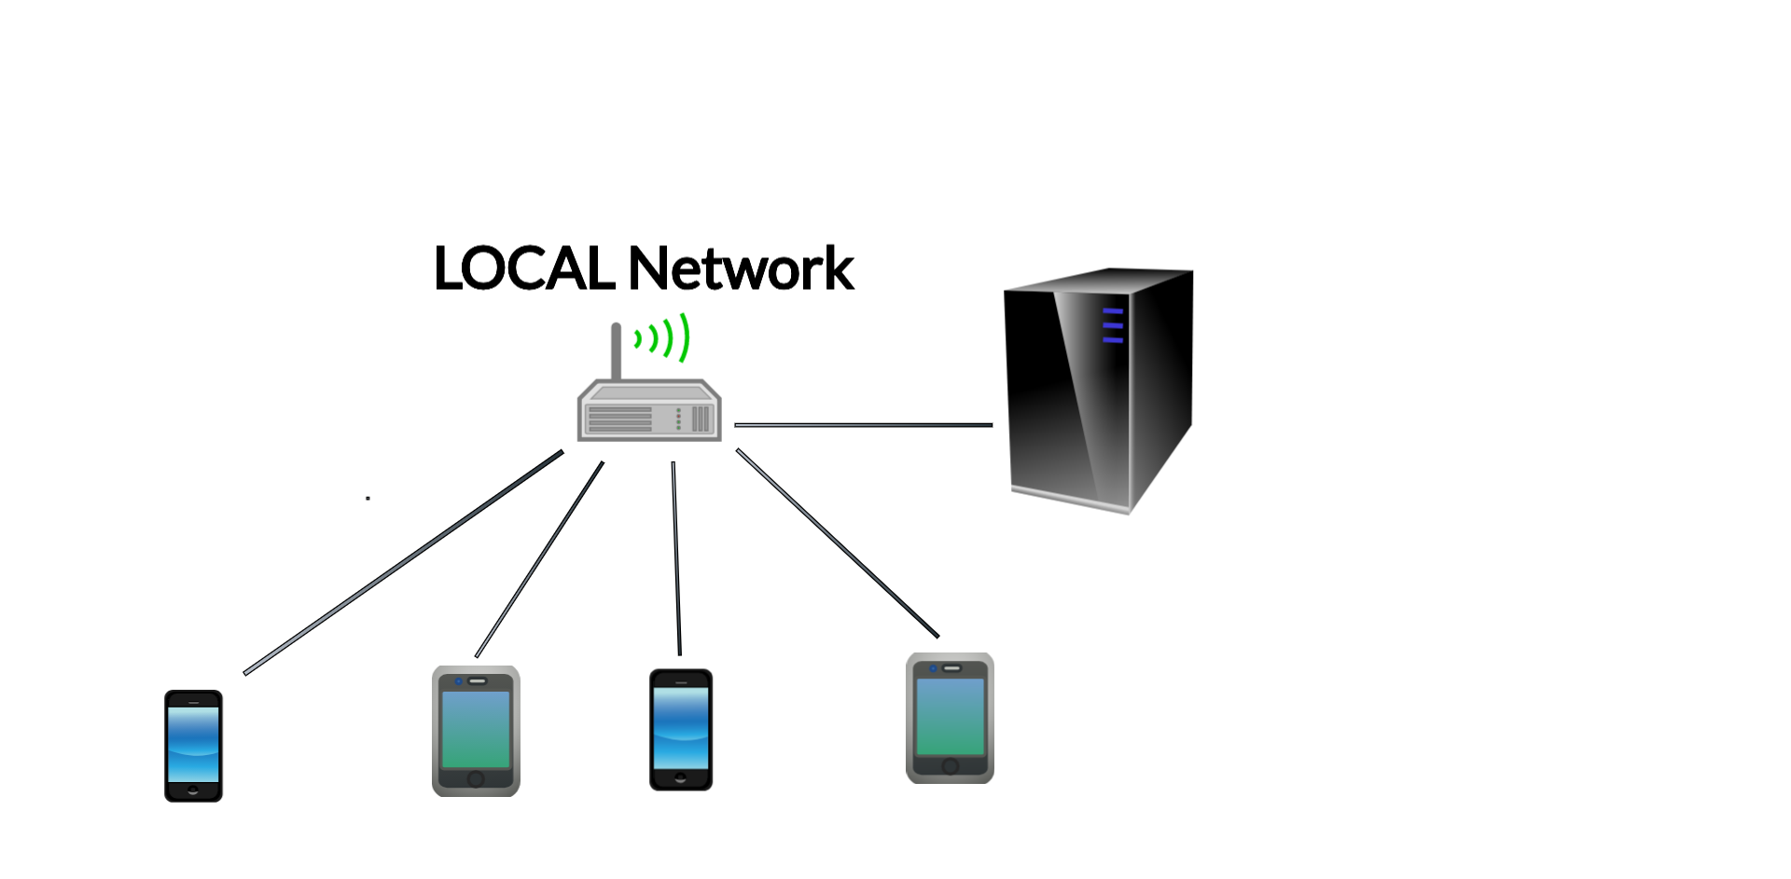  
  
The system consists of the following modules:  
1)Audience Area 2)Administration Area 3)Data Storage 4)Data Processing 5)Data Analytics 6)Reporting

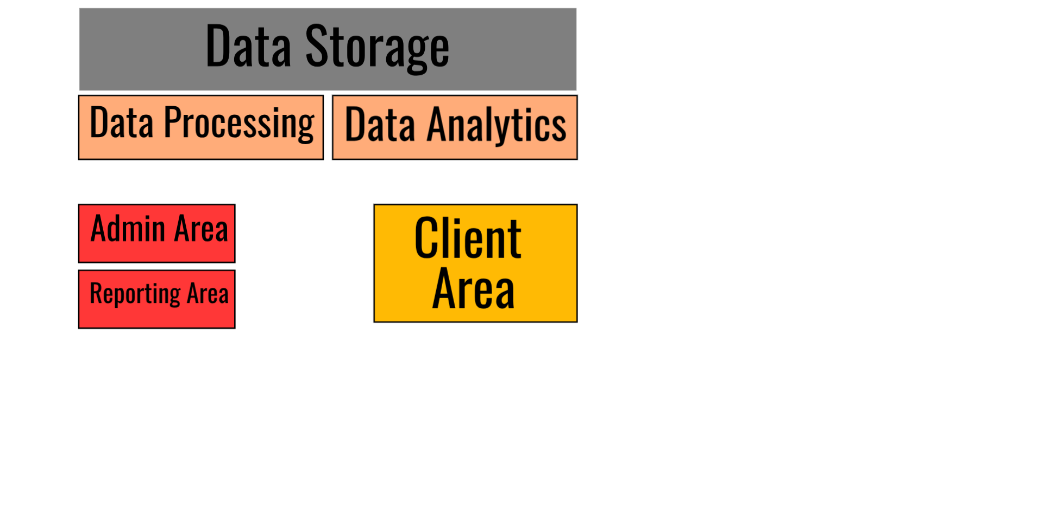**Storage**The system uses different types of storage:

* System storage for system configurations.
* Admin data storage for storing data by admin.
* Audience data storage for storing all inserted data by audience and admin.
* Analytics storage for storing outcomes of data analytics module.

System storage uses json format to store the data in a text file on the server locally.

Audience data storage uses sqlite database and will be also on the server, no external servers are needed.